|  |
| --- |
| LockedMe.com  (Project Screen Shots) |

**VERSION HISTORY**

|  |  |
| --- | --- |
| AUTHOR | Deepali B. Sandimani |
| PURPOSE | Project Screen Shots |
| DATE | 13th AUG 2021 |
| VERSION | 1.0 |

**TABLE OF CONTENTS:**

1. Main Menu
2. Display All Files
3. Add a file
4. Delete a file
5. Search a file
6. **Main Menu :**

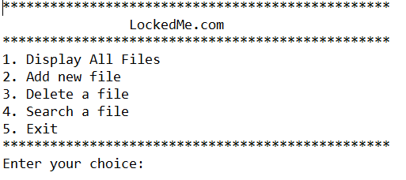

1. **Display All Files:**

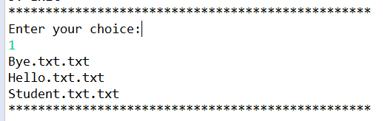

1. **Add a file:**

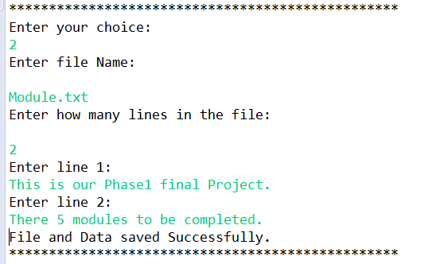

1. **Delete a file:**

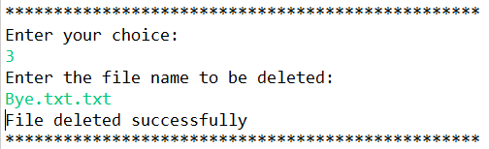

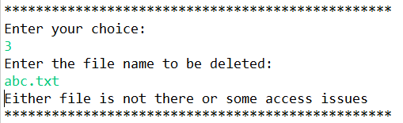

1. **Search a file:**

